HOWTO: File Encryption with TrueCrypt

Purpose: This guide attempts to explain how to install and use the application TrueCrypt to create encrypted file containers to password-protect sensitive data.

Software: The only software needed is TrueCrypt. It is available on the creators' website and is included on this CD for your convenience. For security reasons, we recommend downloading the software from its official website and verifying the checksum.
(http://www.truecrypt.org/)

Nutshell:
First, we are going to install TrueCrypt. TrueCrypt will allow you to create an encrypted file container, or encrypt an entire disk drive. The containers act just like password-protected folders, keeping your private data safe from prying eyes.

Second, we will create an encrypted file container.

Third, we will test our container by opening the container, adding a file, and closing it. Then we will open it again to verify it works properly.

Last, we will discuss a few advanced options, like keyfiles, whole drive encryption, and hidden volumes.

For further information, we recommend consulting TrueCrypt's own tutorial, located at: http://www.truecrypt.org/docs/tutorial

Part I: Install TrueCrypt
- Obtain the TrueCrypt installation file from the website (http://www.truecrypt.org/) or use the installation file on this CD.
- OSX – Double-click TrueCrypt 7.1a.dmg, double-click TrueCrypt 7.1a.mpkg. Click Continue twice and then Install. Enter your password to allow the program to install.
WINDOWS – Double-click TrueCrypt Setup 7.1a.exe. Allow the program to run, choose to accept the license, and then click Next until the installation completes. You can customize the options if you wish, but the default options are okay.

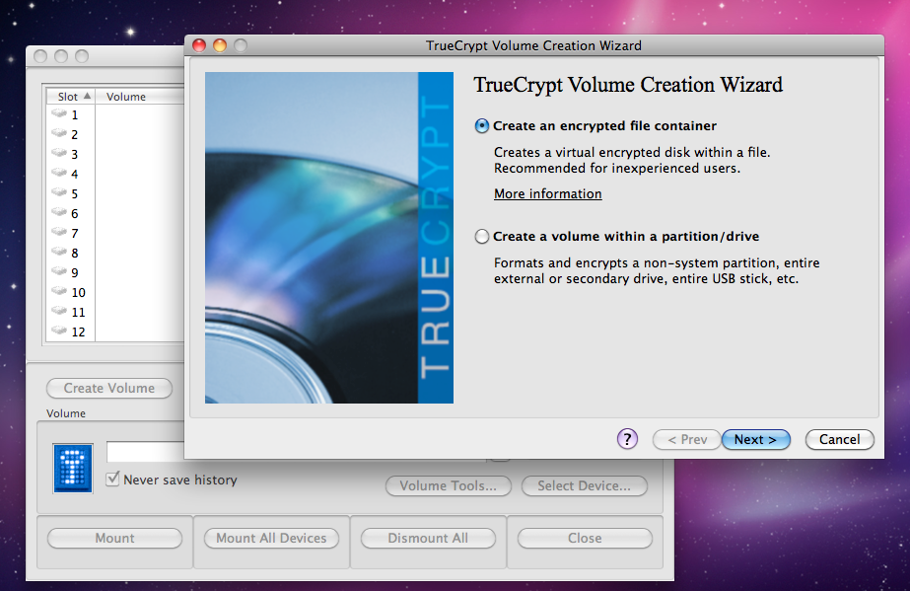
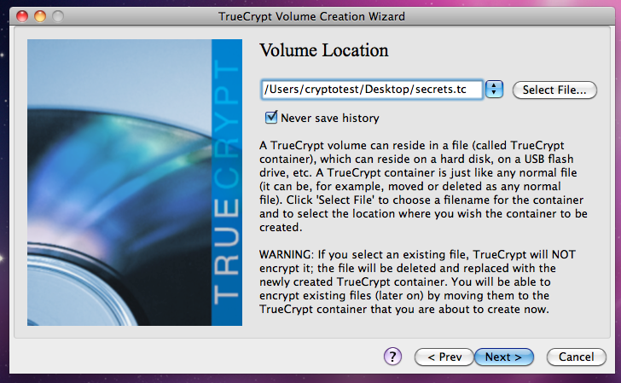
Part II: Create an Encrypted File Container

- OSX – Double-click TrueCrypt in your Applications folder.
WINDOWS – Click Start > Programs > TrueCrypt > TrueCrypt
- Click the Create Volume button. (Windows TrueCrypt should be nearly identical in content and format to the OS X screenshots here, but has a different style.)
- Choose “Create an encrypted file container” and press Next >
- Choose “Standard TrueCrypt volume” and press Next >
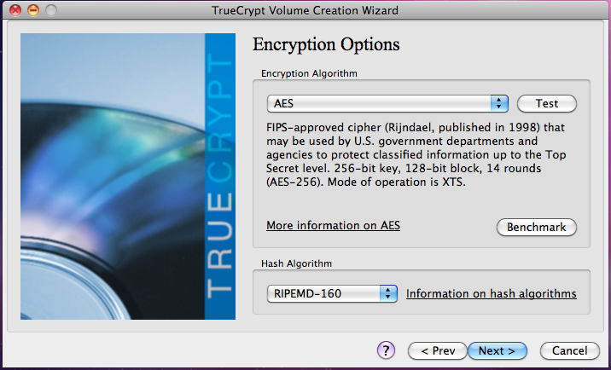
- Choose a location and filename for this container. You can save it wherever you want, and use whatever filename and extension you want. If you use the extension “.tc”, the file will automatically open in TrueCrypt on Windows. Click Next >

- For our first container, we will keep it simple. Just click Next > on the Encryption Options screen. The default provides a good level of security while remaining very efficient.
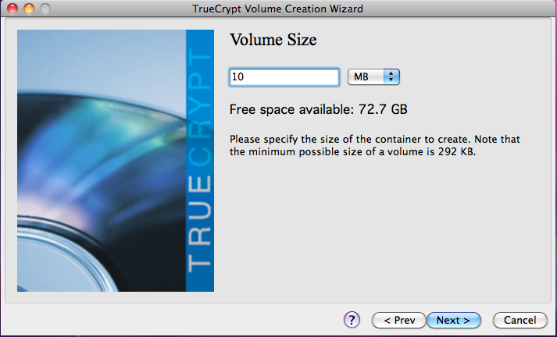
- Select a size for your volume. Make sure it is big enough to hold whatever files you want to encrypt. For now, pick a small size, like 10MB. Click Next >
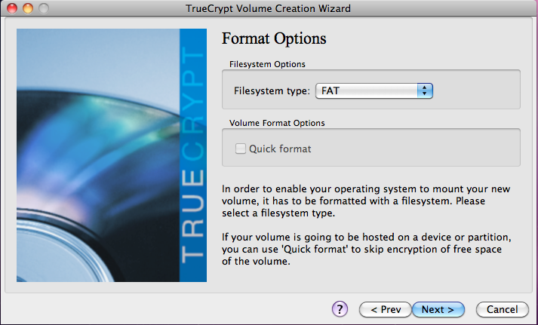
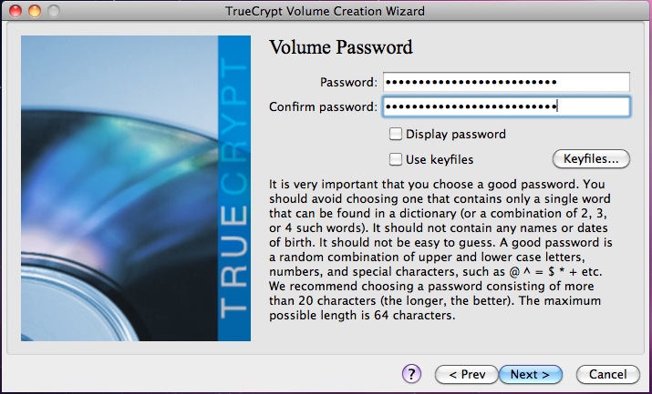
- Choose a password for your volume. This is the password you will use every time you open up the container. If you forget this password, any data stored in the container will be lost (that is, stuck in its encrypted form). We recommend you choose the longest and most complex password you can possibly tolerate typing every time you need to access the encrypted files. Alternatively, we recommend using keyfiles, which are discussed below in Part III. Type the password twice and press Next >.

- On the Format Options screen, just click Next >. For best compatibility with various operating systems, we recommend using FAT. The only notable limitation is that FAT does not allow you to have files larger than 4GB each. (Your container can still be virtually as big as you want, but no file inside it can be larger than 4GB.)

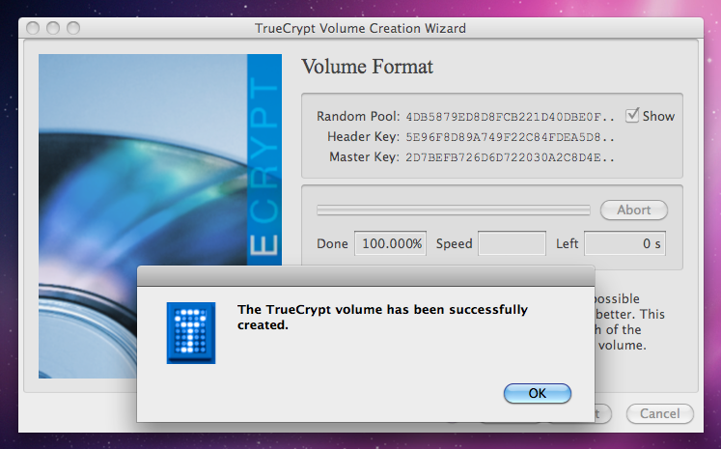
- This is the most important step. When you get to the Volume Format screen, read the IMPORTANT paragraph near the bottom. Spend as long as you can stand randomly moving your mouse around in this window. The longer you do it, and the more random the movements are, the stronger your encryption key will be. You only have to do this once, and you never have to deal with your encryption key directly, so spend a few minutes and make it count. Once you have moved your mouse around for as long as you could stand, click Format.
- You have now created your first encrypted file container with TrueCrypt!

Part III: Test Your TrueCrypt File Container
- Open TrueCrypt
- Click a drive letter or slot number, then click Select File...
- Select the file container you created in the steps above. Click Open
- Click Mount in the main TrueCrypt window, then enter the password you created in the steps above. Click OK
- If you typed your password correctly, the volume should appear in the slot you selected. To access the encrypted volume:
WINDOWS: Go to My Computer and open the drive letter that you selected.
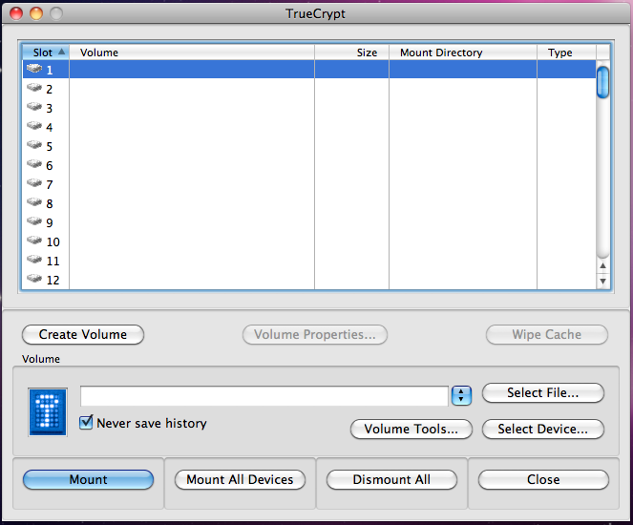
OSX: Find the volume in the Finder under Devices, or on the Desktop

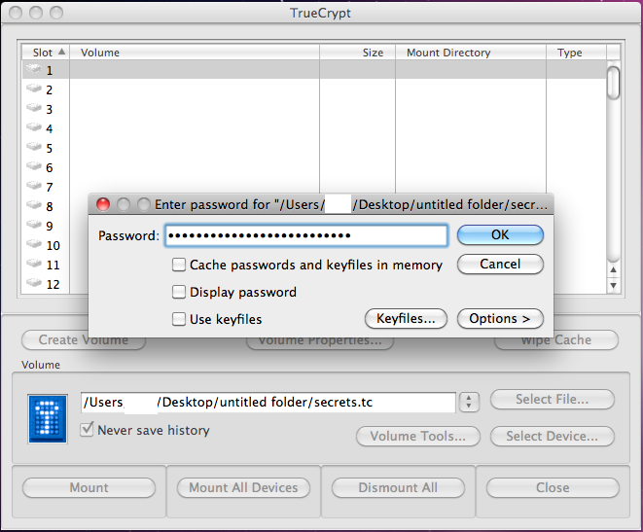
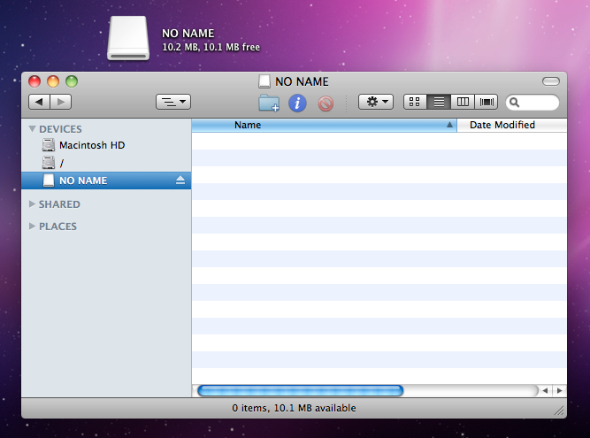
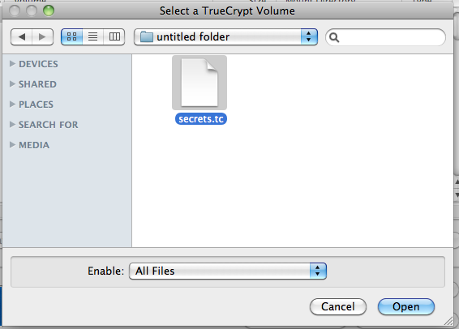
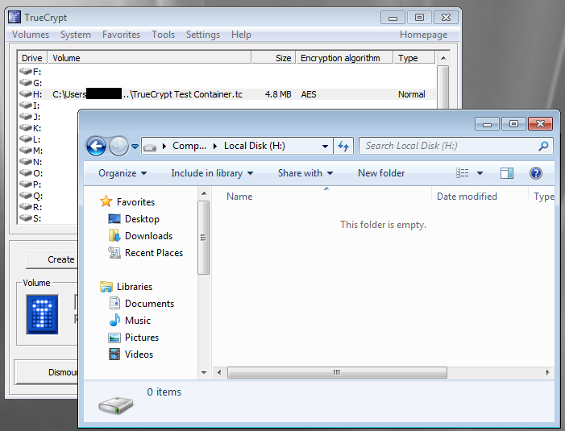
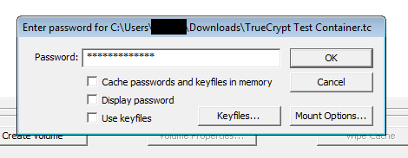
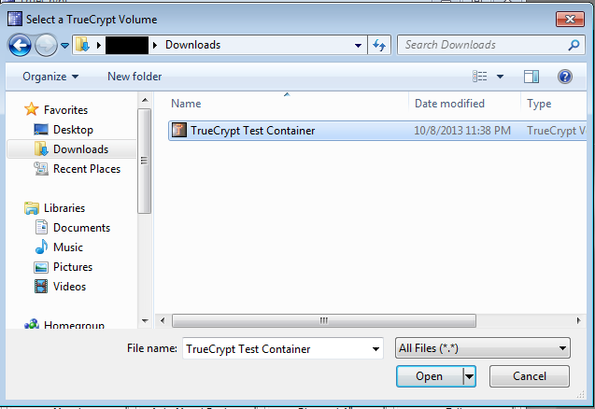

- Now, add a file to your container. Since we are just practicing, you can use any file, even the files on this CD. Simply drag the file into the container; it works like any other folder. This will copy the file, not move it, so when you use this with actual private data, you may want to delete the unencrypted original file after you have verified that the encrypted copy works.
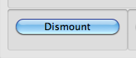

- After you have added the file(s) and you are done using them, you will want to dismount the volume. To dismount the volume, select the drive letter or slot number in the main TrueCrypt window, and click Dismount. This makes sure that anyone who wants to access the files will need the password. If you do not dismount the volume, anyone with access to your computer can simply open up the container and view the contents. Think of mounting and dismounting as unlocking and locking, respectively. You mount (or unlock) the file container using your password so you can add files or use the files that are already there. When you're done, dismount (or lock) the container so your files are secure.
OS X WARNING: Never, ever, click the Eject symbol next to the name of the file container volume or click Eject in the right-click menu for the volume. This can cause TrueCrypt to freeze, and could possibly result in data loss. Always use the Dismount button in the main TrueCrypt window. Always.
- Now, let's try it out. Repeat steps 2 through 4 and see if your file is there in your encrypted container. If you see the file you added, you're done. Don't forget to Dismount your volume. Now you can use TrueCrypt to securely store any private documents or files you want. For fun, try typing your password wrong when you mount the volume so you can see what will happen. For more advanced fun, open the TrueCrypt volume file with a Hex or Text editor to view the beautiful randomness inside (but don't change anything!).

Part IV: Advanced Options
- Keyfiles
One way to increase the security of your TrueCrypt container is by using keyfiles instead of, or in addition to, the password. Create a container normally, but when you get to the password selection screen, check the box next to “Use Keyfiles”. Then, click the Keyfiles... button to select the files and/or folders you want to use. Key files work just like passwords, but instead of typing a password you select a file on your computer. Since the contents of the file are used like the password, it is absolutely imperative that your keyfile(s) is not modified. You must use identical files to unlock the volume as the ones used when it was created.
For more information on keyfiles, please consult TrueCrypt's documentation: http://www.truecrypt.org/docs/keyfiles
- Encrypting Entire Drives
If you want to encrypt an entire USB drive or a non-system partition on your computer, click Create Volume and select the “Encrypt entire drive/partition” option in Windows, or the “Create a volume within a partition/drive” option on OS X. Proceed normally until you get to the Volume Location screen. Select the drive you want to encrypt, and click next. This will FORMAT the selected drive and DELETE all files currently on it. Click Next > and proceed with the rest of the installation as normal.
NOTE: Windows and OS X may both give you warnings about the drive not being readable when you connect it later. Click Ignore, cancel, or anything except for Format. You will need to open TrueCrypt and choose “Select Device” instead of “Select File...”
- Hidden TrueCrypt volumes
You can create TrueCrypt volumes that are virtually impossible to verify even exist without having the password. This works by creating an outer volume and an inner volume. The outer volume acts as a decoy. You can fill it with slightly sensitive but not highly important data, so that way it looks legitimately private. The inner volume can be used to contain more highly sensitive data.
The outer layer and the inner layer have different passwords. If you enter the password for the outer layer, TrueCrypt will mount the volume and all you will see is the decoy contents of the outer layer. If you enter the password for the inner layer, TrueCrypt will mount the volume containing only your more highly sensitive data.
The basic idea is that this way, if someone else gets their hands on your encrypted drive, and they also have some way to force you to give up the password, you can give up the password to the outer volume. They will only be able to see the decoy files, and they have no way of determining if there is a hidden volume.

